This is the Title of the paper for cmc2006
Juan Valdés & John M. Smith, Universidad del Mapeo Conceptual, España
Mario James, University of Map, Germany
Email: Jvaldes@universidad.edu, www.mapping.org

Abstract. Finding relevant information on the Internet can be a daunting task which would be enhanced if the material were organized and could be accessed in an efficient manner. Browsers based on a concept map-based interface and on a World Wide Web page-based interface were compared for ease in finding information necessary to answer a series of search questions based on the same domain material (developmental psychology). Users differed in the amount of concept map training they received and the type of learner they tended to be (meaningful vs. rote learners). The results indicated that the concept map-based interface resulted in better search performance for all learners although this difference was most pronounced for meaningful learners. Training in concept map construction appeared to have no more effect on search performance using the concept map-based interface, than control conditions. Taken together, the results suggest that organizing information via a concept map-based interface leads to more accurate search performance than the typically used web page-based browser.

Introduction
Concept mapping is a process of meaning-making. It implies taking a list of concepts – a concept being a perceived regularity in events or objects, or records of events or objects, designated by a label (Yates & Ribeiro-Neto, 1999; Cañas et al., 2000) – and organizing it in a graphical representation where pairs of concepts and linking phrases form propositions. Hence, key to the construction of a concept map is the set of concepts on which it is based. Coming up with an initial list of concepts to include in a map is really just an issue of retrieving from long-term memory. In fact, rote learners are particularly good at listing concepts. A more difficult task during concept map construction is finding the “linking phrase” that appropriately expresses the relationship between two concepts to form a meaningful proposition.

Often, while constructing a concept map, users –whether elementary school students, scientists or other professionals– pause and wonder what additional concepts they should include in their map, or what words to use to clearly express the relationship between two concepts. Even though they know well the domain they are modeling, they cannot “remember” what other concepts are relevant, can’t think of the “right word”, or sometimes they need to “refresh” their knowledge about a particular sub-domain of the concept map (Chakrabarti et al., 1998).

Aiding Model Extension
An initiative is now under way to develop methods to aid the user during concept map construction. These aids are designed in response to observations of snags which may arise during concept mapping. During concept mapping, users often stop and wonder what other concepts they should add to the concept map they are working on, frequently spending time looking for the right word to use in a concept or linking phrase; they search for other concept maps that may be relevant to the one they are constructing, and they search through the Web looking for additional material that could help them enhance their maps. The following sections describe three methods developed to address these issues.

Suggester for Concepts

The goal of the concept suggester is to facilitate concept map construction by proactively searching and suggesting new concepts to the user (Novak & Gowin, 1984). In contrast to the proposition and resource suggester, discussed in the next section, the concept suggester proposes collections of terms, each of them representing a concept that is novel (i.e., not contained in the current map) but potentially relevant. This can (1) help the user to remember familiar concepts that might otherwise be forgotten, and (2) give the user the opportunity to further explore and understand new and potentially relevant concepts.

The search for relevant concepts is a two-step process. The system first searches the Web for documents related to the current map (Novak, 1998; Pearsall, Skipper, & Mintzes, 1997), to cache a collection of documents that can then be mined, in the next step, for the concepts to be suggested. The state of the map under construction is continuously monitored for significant changes that could trigger a new search for concepts to add to the cache (Error: Reference source not found1 shows the process). Significant changes in the map are defined as any modifications of the root, the hubs, or the authority nodes (Reynolds & Dansereau, 1990; Spiro, Feltovich, Jacobson, & Coulson, 1992). Such modifications may affect the relevance of cached documents to the current context, thus requiring the system to launch a new search.

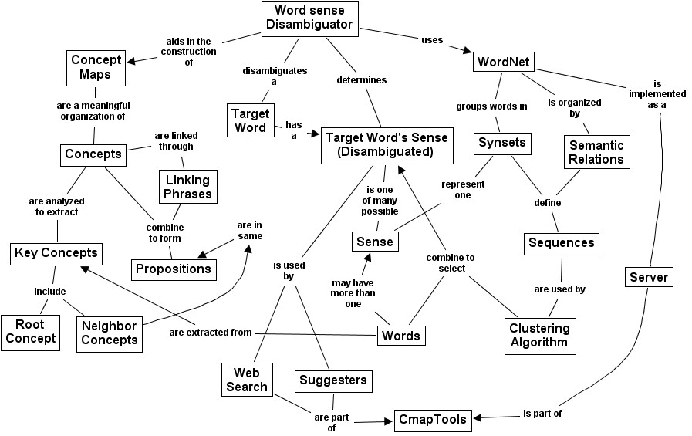
Figure 1. This is a caption for figure one This is a caption for figure one This is a caption for figure one and one.

This is a Third Level Header
This is the beginning of a paragraph. And this is the start of a list.

- List bullet 1
- List bullet 2
- List bullet 3 can continue on and on and on

Or, the list can be numbered, as in the following:

- First item.
- This is the second item of the list.

Target Concept Maps and most relevant terms of six  Artificial Topics | Topic 1:  technology  penetration  revolutionary  systems  protection |  | Topic 2:  air  dry  composition  nitrogen  oxygen |  | Topic 3:  entry  atmosphere  system  esa  level |  | Topic 4:  landing  sites  specific  nasa  mars |  | Topic 5:  mars  lowell  history  percival  planet |  | Topic 6:  fluvial  history  erosion  activity  glaciers
Originating Map | 0.1 | 0 | 0 | 0 | 0.25 | 0 | 0.4 | 0 | 0.15 | 0 | 0.3 | 0
Climate History | 0 | 0 | 0.15 | 0.15 | 0.15 | 0.2 | 0.05 | 0.08 | 0.1 | 0.05 | 0.7 | 0.72
Deep Access | 0.75 | 0.72 | 0.05 | 0.05 | 0.2 | 0.2 | 0.15 | 0.08 | 0.1 | 0.05 | 0.1 | 0
Earth’s Atmosphere | 0 | 0 | 0.5 | 0.5 | 0 | 0 | 0 | 0 | 0 | 0 | 0.1 | 0.07
Geologic History | 0 | 0 | 0 | 0 | 0 | 0 | 0.05 | 0.08 | 0.1 | 0.05 | 0.3 | 0.28
Landers | 0 | 0 | 0 | 0 | 0.1 | 0.13 | 0 | 0 | 0.05 | 0 | 0.5 | 0.5
History of Water | 0.2 | 0.16 | 0.1 | 0.1 | 0.7 | 0.6 | 0.55 | 0.41 | 0.05 | 0 | 0.15 | 0.14
Myth & Science Fiction | 0.05 | 0 | 0 | 0 | 0.05 | 0 | 0.1 | 0 | 0.7 | 0.7 | 0.05 | 0
Pathfinder | 0.05 | 0 | 0.05 | 0.05 | 0.25 | 0.2 | 0.15 | 0 | 0.1 | 0 | 0.05 | 0.07
Rovers | 0.35 | 0.27 | 0 | 0 | 0.55 | 0.46 | 0.5 | 0.33 | 0.1 | 0 | 0.2 | 0.14
Table 1: Caption for Table

Data Fitting

Evaluation
The usefulness of EXTENDER's suggestions is difficult to assess in a controlled way, because the cohesiveness and usefulness of topic suggestions is highly subjective. In order to perform an objective test of whether the system was able to generate artificial topics with content similar to hand crafted ones, we performed an automatic evaluation of the system using the Mars 2001 knowledge model (Wandersee, Mintzes, & Novak, 1994). The top-level concept map from the knowledge model (chosen as the most basic) was used by EXTENDER as the starting point (representing the map under construction) and EXTENDER was used to produce a collection of artificial topics, without access to any of the other maps in the knowledge model. We then determined the overlap between EXTENDER's topics and those that an expert had actually chosen to include in the knowledge model (Willerman & Mac Harg, 1991). This was measured by two rate functions.

Rate1 measures the proportion of terms in an artificial topic that are actually part of a target concept map. Given a set T of terms in a topic and a set C of terms in a target expert concept map, this rate is computed as follows:
${\text{Rate}}_{1}(T,C)=\frac{|T∩C|}{|T|}$.
Rate₂ represents the proportion of novel terms (terms not in the starting map) in an artificial topic that are also part of a target concept map. not in the starting model. Consider the set O, containing the terms of the originating concept map. If T ⊆ O, then no novel terms were generated and Rate₂ returns 0. Otherwise,

${\text{Rate}}_{2}(T,C,O)=\frac{|(T∩C)−O|}{|T−O|}$.
While Rate₁ shows the degree to which an artificial topic resembles a given map, Rate₂ shows the proportion of novel terms in an artificial topic that are also part of a target map, but are not in the starting model.

Summary
This is the summary of this article.

Acknowledgements
This Research Project was supported by Grant #CMC-200-19-4 from the Concept Mapping Foundation. We thank Joe Doe and Jane Smith for their critical review of previous version of the manuscript and Mary Lamb for her assistance during data collection.

References
Cañas, A. J., Ford, K. M., Coffey, J., Reichherzer, T., Carff, R., Shamma, D., & Breedy, M. (2000). Herramientas para Construir y Compartir Modelos de Conocimiento basados en Mapas Conceptuales. Revista de Informática Educativa, 13(2), 145-158.
Chakrabarti, S., Dom, B., Gibson, D., Kleinberg, J., Raghavan, P., & Rajagopalan, S. (1998). Automatic Resource List Compilation by Analyzing Hyperlink Structure and Associated Text. Paper presented at the 7th International World Wide Web Conference.
Novak, J. D. (1998). Learning, creating, and using knowledge: Concept Maps as Facilitative Tools in Schools and Corporations. Mahweh, NJ: Lawrence Erlbaum Associates.
Novak, J. D., & Gowin, D. B. (1984). Learning How to Learn. New York: Cambridge University Press.
Pearsall, N. R., Skipper, J., & Mintzes, J. (1997). Knowledge restructuring in the life sciences: a longitudinal study of conceptual change in biology. Science Education, 81(2), 193-215.
Reynolds, S., & Dansereau, D. (1990). The knowledge hypermap: An alternative to hypertext. Computers in Education, 14(5), 409-416.
Spiro, R. J., Feltovich, P. J., Jacobson, J. J., & Coulson, R. L. (1992). Cognitive Flexibility, Constructivism, and Hypertext: Random Access Instruction for Advanced Knowledge Acquisition in Ill-Structured Domains. In T. M. Duffy & T. D. H. Jonassen (Eds.), Constructivism and the Technology of Instruction: A Conversation (pp. 57-75). Hillsdale, NH: Lawrence Erlbaum Associates.
Wandersee, J. H., Mintzes, J. J., & Novak, J. D. (1994). Learning: Alternative Conceptions. In D. L. Gabel (Ed.), Handbook on Research in Science Teaching (pp. 177-210). New York: Macmillan.
Willerman, M., & Mac Harg, R. A. (1991). The concept map as an advance organizer. Journal of Research in Science Teaching, 28(8), 705-711.
Yates, R. B., & Ribeiro-Neto, B. (1999). Modern Information Retrieval. MA: Addison Wesley.

